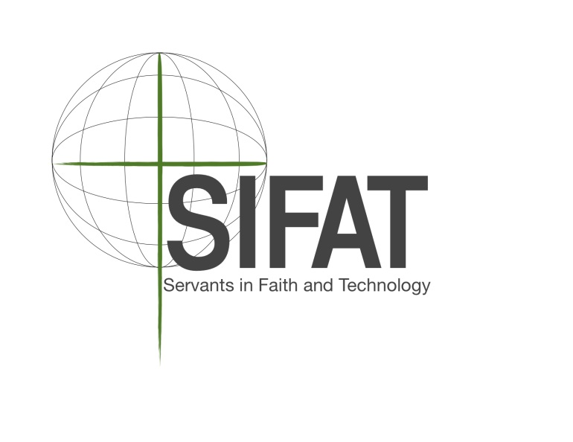

2016 Farm to Table Garden Internship Program

SIFAT is offering a 2-month internship with our Farm to Table Garden Program for the 2015 summer growing season (May - July). This internship provides a unique opportunity to learn by working in the garden and preparing food in the kitchen at the same time. Working in collaboration with the Agricultural Coordinator and food service personnel, the Farm to Table Intern will contribute to each step of the produce's life, from building the soil to the finishing touches in the kitchen!

About SIFAT:

Servants in Faith and Technology (SIFAT) is an international Christian nonprofit organization. We merge faith and appropriate technology for the purpose of enabling international community leaders to go back to their countries and train their own people who are struggling to meet their basic needs of food, water and shelter. Since its foundation in 1979, SIFAT has trained community leaders from 87 countries around the world. We have a 176 acre campus in Lineville, AL that serves as our “home base”. On our campus we hold two annual trainings to equip these international community leaders.

Goal of the Farm to Table Internship:
- Create and implement a relationship between the SIFAT gardens and Cafeteria, where the menu changes daily based on what was picked at the farm that day.

Job Description:
- Plant, cultivate, and harvest SIFAT produce as instructed by the Agricultural Coordinator
- Clean and store all produce properly
- Cook and prepare food for Campus guests
- Teach food service personnel proper preparation and cooking techniques for produce
- Plan daily menu in accordance with available SIFAT and local produce
- Place weekly food order through SYSCO
- Supplement supplies with local grocery store items as needed
- Equip Learn & Serve participants and staff with an understanding of the importance of fresh produce grown locally
- Provide SIFAT Campus guests with healthy food that they will enjoy!
- Educate Campus Cafeteria guests, and all food service personnel on nutritional information (and the importance) of food being served
- Teach 7th – 12th grade Learn & Serve students agricultural techniques, appropriate technologies, etc. as instructed by L&S Program Director

*Dates of Internship: May 10 – August 2, 2016
*Off the week of TBD
*Off all Saturdays

Financial Compensation: SIFAT offers Farm to Table Interns a weekly salary of $175. The weekly salary is in accordance with the dates of internship, May 10 – August 2. With one designated “off” week, the Intern will be compensated for a total of 11 weeks.
2016 Farm to Table Garden Internship Application

Name: _______________________________________________________________________
Address: _____________________________________________________________________
Phone: ______________________________ Email: __________________________________
Age/Date of Birth: ____________________ Gender: _________________________________

Employment History: Please list your last two places of employment.
- Business: __________________________ Supervisor: _________________________
Address: ___________________________ Phone: ____________________________
Dates of Employment: ___________________________________________________
- Business: __________________________ Supervisor: _________________________
Address: ___________________________ Phone: ____________________________
Dates of Employment: ___________________________________________________

Character References: Please list two non-family member character references.
- Name: ____________________________ Phone: _____________________________
Relationship to You: _____________________________________________________
Email: _________________________________________________________________
- Name: ____________________________ Phone: _____________________________
Relationship to You: _____________________________________________________
Email: _________________________________________________________________

Thank you for your interest in applying for a SIFAT 2015 Farm to Table Internship position! Throughout the summer, FT Interns will work closely with one another and with other SIFAT staff. Please answer the following questions with honesty and clarity, so that we may evaluate your qualification for an internship position.

- How did you hear about SIFAT and this position?

- What is your current occupation? (If you are a student, what are you studying, and where? If you have a job, what are your responsibilities? etc.)

- Why are you interested in SIFAT’s Farm to Table Internship Position? Please elaborate.

- Do you have any experience working with 7th – 12th grade youth?

- What public speaking and/or teaching experience do you have, if any?

- Do you have any food service experience? If so, please explain.

- Please list any additional skills you have that may be beneficial to working within them Farm to Table Internship program.

- The SIFAT Farm to Table internship involves many different kinds of work—which aspects of this position (see job description) are you most interested in, and what skills do you hope to acquire through this internship?

- How would you characterize the role food plays in your life, and what experiences have shaped this relationship?

- Can you foresee any reason why you would not be able to complete the entire summer on staff?

- Please describe any ministry experience you have.

- When do you feel closest to God?

Please return completed application to:
SIFAT: Learn & Serve
2944 County Road 113
Lineville, AL 36266
-OR- email completed application to: learnandserve@sifat.org
If you have any questions, please call 256-396-2015 or e-mail learnandserve@sifat.org

Applications must be submitted to SIFAT no later than January 31, 2016

