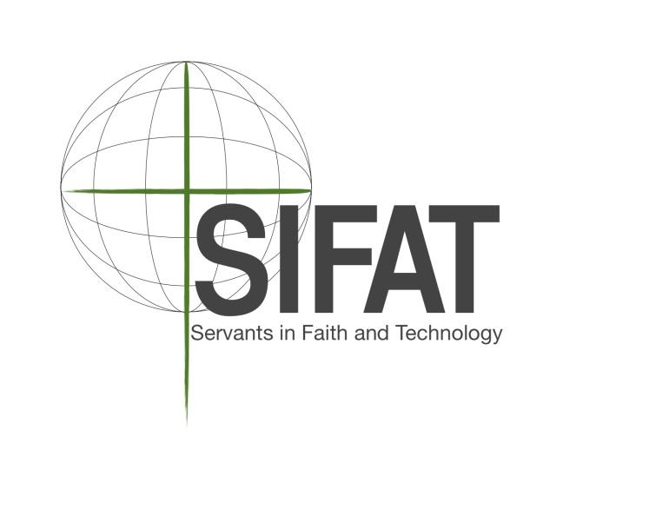

Farm to Table
Internship Program

The Galilee Campus of SIFAT is offering a 10 week internship with our Garden Program & Hospitality Program for the summer growing season (May 18 - August 5). This internship provides a unique opportunity to learn by working in the garden and preparing food in the kitchen at the same time. Working in collaboration with the Agricultural Coordinator and Hospitality personnel, the Farm to Table Intern will contribute to each step of the life of the produce, from building the soil to the finishing touches in the kitchen!

About SIFAT:

Servants in Faith and Technology (SIFAT) is an international Christian nonprofit organization. We merge faith and appropriate technology for the purpose of empowering international community leaders to go back to their countries and train their own people who are struggling to meet their basic needs of food, water and shelter. Since its foundation in 1979, SIFAT has trained community leaders from 92 countries around the world. The Galilee Campus is a 176 acre campus in Lineville, Alabama that serves as our “home base.”

Goal of the Farm to Table Internship:
Cultivate and develop an ongoing mutually beneficial relationship between the gardens and cafeteria, where the menu changes based on the harvest.

Job Description:
- Plant, cultivate, and harvest SIFAT produce as instructed by the Agricultural Coordinator in the Galilee Campus gardens as well as village gardens
- Clean and store all produce properly
- Cook and prepare food for Campus guests
- Plan daily menu alongside Hospitality in accordance with available SIFAT and local produce
- Place minimal weekly food order with the help of Hospitality
- Equip Learn & Serve participants and staff with an understanding of the importance of fresh produce grown locally
- Provide SIFAT Campus guests with healthy food that they will love
- Educate Campus Cafeteria guests, and all food service personnel on nutritional information (and the importance) of food being served
- Implement practical composting processes for the campus and our guests
- Implement recycling processes for the campus and our guests
- Learn and be able to teach WaterWatch, Leaf for Life, Composting & Bug School Workshops as needed
- Implement Community Gardens Program with local community
- Teach students young and old agricultural techniques, appropriate technologies, etc. as instructed by the Campus Program Manager

*Dates of Internship: May 18 - August 5, 2018
*Off the week of July 4

Financial Compensation: Your experiential learning will be invaluable. You will receive a two week class that could be worth 3 credit hours (depending on your university) at no cost to you. You will be given housing and meals Sunday evening through Friday lunch. If needed you may fundraise a stipend for your time on the campus. Training for fundraising will be provided before your arrival on campus at a time to be determined.
2018 Farm to Table Internship Application

Name:
Address:
Phone: Email:
Age/Date of Birth: Gender:

Employment History: Please list your last two places of employment.
- Business: Supervisor:
Address: Phone:
Dates of Employment:
Business: Supervisor:
Address: Phone:
Dates of Employment:

Character References: Please list two non-family member character references.
- Name: Phone:
Relationship to You:
Email:
- Name: Phone:
Relationship to You:
Email:

Thank you for your interest in applying for a Farm to Table Internship position! Throughout the summer, FT Interns will work closely with one another and with other SIFAT staff. Please answer the following questions with honesty and clarity, so that we may evaluate your qualification for an internship position.

- How did you hear about SIFAT and this position?

- What is your current occupation? (If you are a student, what are you studying, and where? If you have a job, what are your responsibilities? etc.)

- Why are you interested in SIFAT’s Farm to Table Internship Position? Please elaborate.

- Do you have any experience working with youth of any age?

- What public speaking and/or teaching experience do you have, if any?

- Do you have any food service experience? If so, please explain.

- Please list any additional skills you have that may be beneficial to working within them Farm to Table Internship program.

- The SIFAT Farm to Table internship involves many different kinds of work—which aspects of this position (see job description) are you most interested in, and what skills do you hope to acquire through this internship?

- How would you characterize the role food plays in your life, and what experiences have shaped this relationship?

- Can you foresee any reason why you would not be able to complete the entire summer on staff?

- Please describe any ministry experience you have.

- When do you feel closest to God?

Please email completed application to:
SIFAT: Learn & Serve; learnandserve@sifat.org

If you have any questions, please call 256-396-7010 or e-mail learnandserve@sifat.org

Applications must be submitted no later than January 31, 2018

